Functionalities Implemented in Phase5:  
1.List all customers in customer table :  
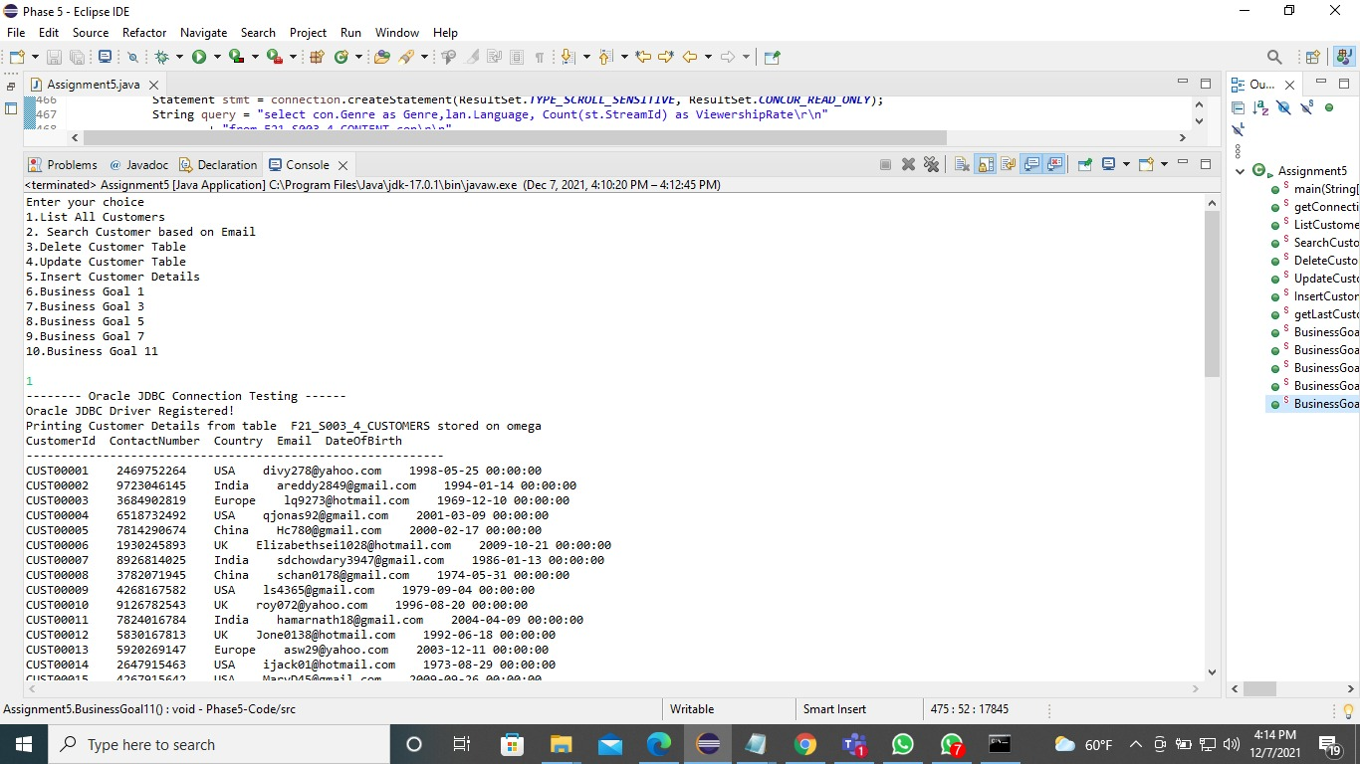

2.Search Customer based on Email  
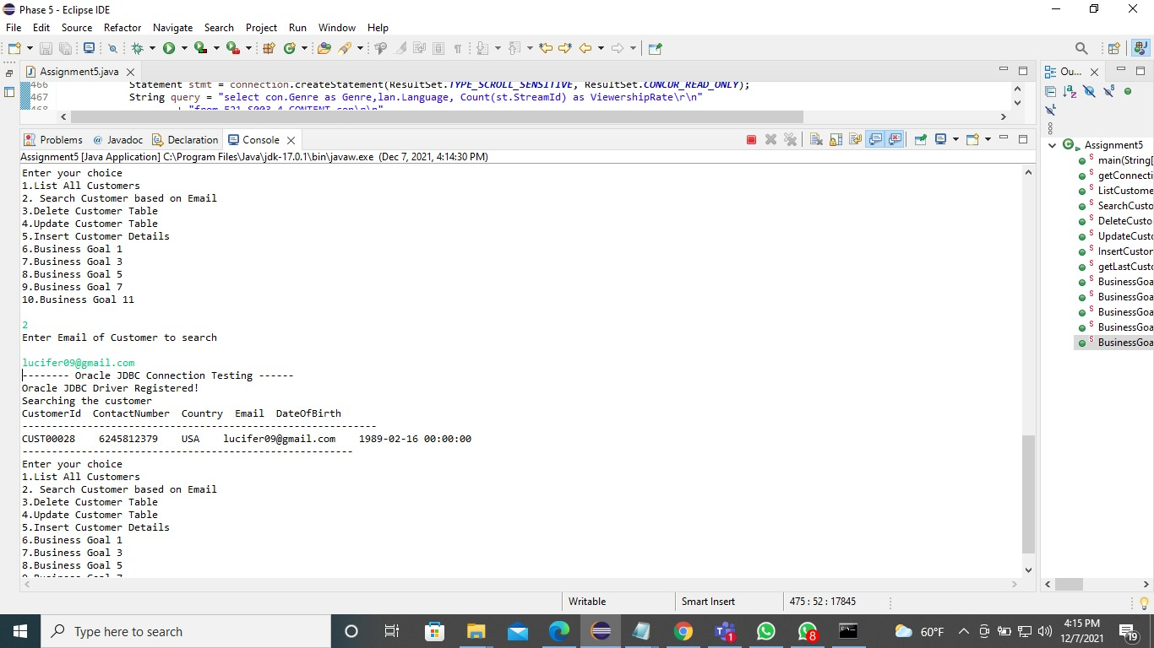

3.Delete Customer from Customer Table  
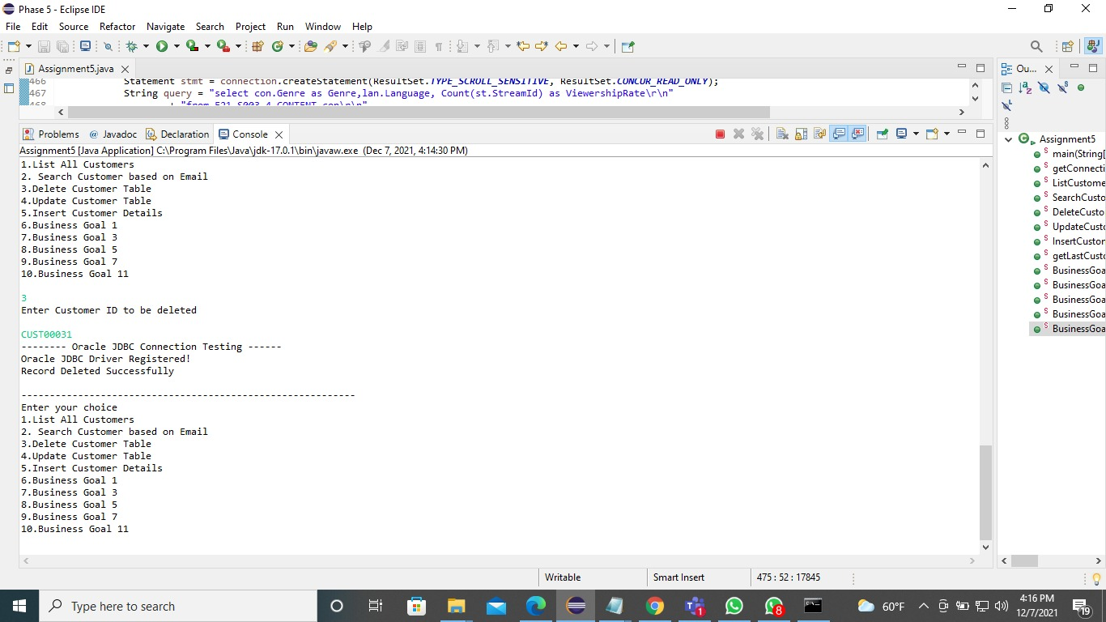

4.Update details of Customer in Customer Table

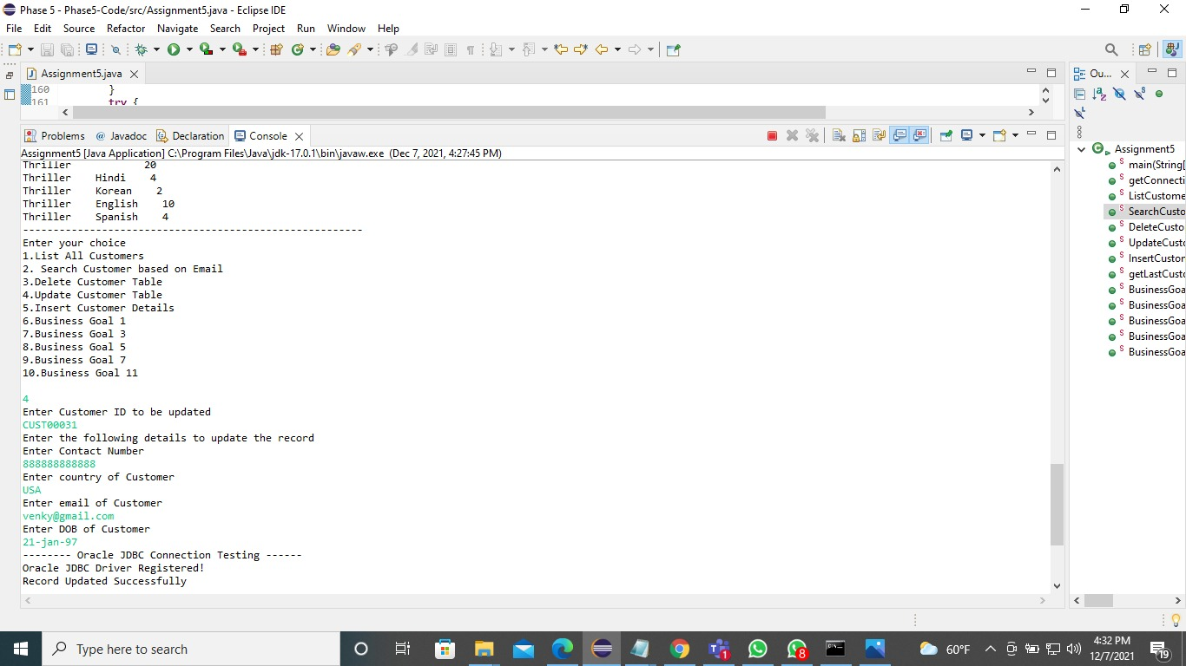

5.Insert a Customer in Customer Table:

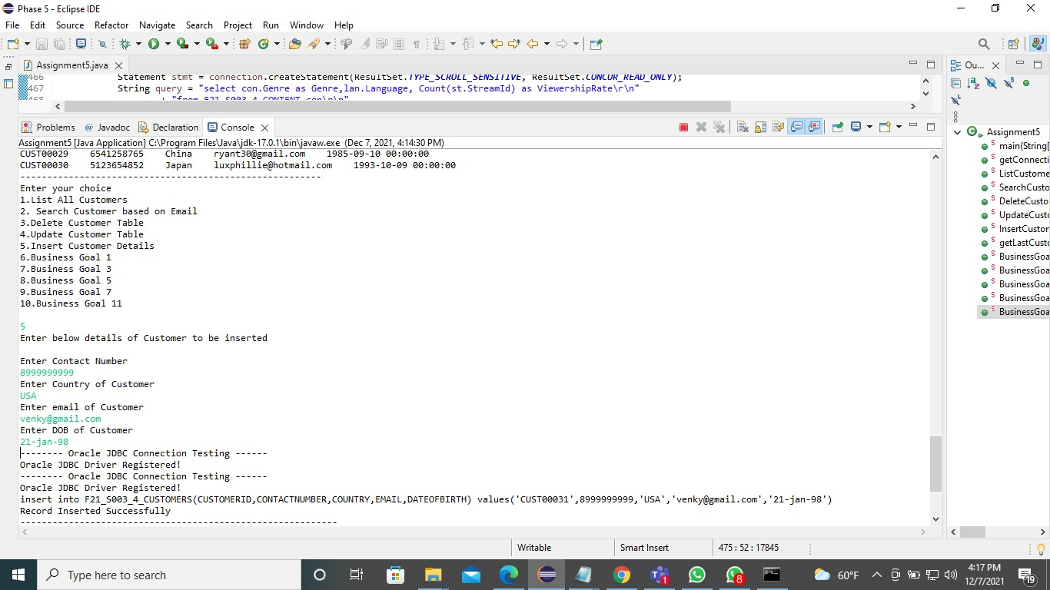

6. To know the interest of customers, we shall generate a report of viewership of each Genre videos in a specific language,so that we can release similar content in that language with atleast 10 streams(Report order by most viewed Genre).  
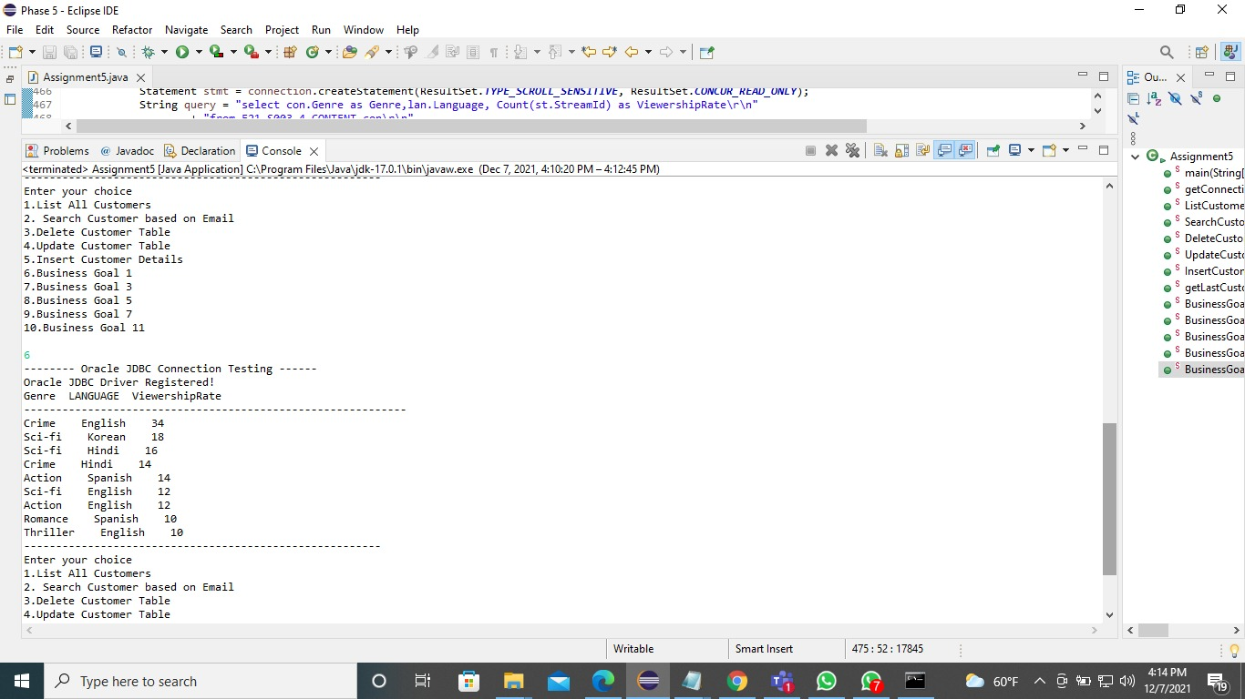

7. Generate yearly report of total customers, who didn’t renew the subscription with respect to each region/country; so that more strategies can be employed to increase the sales (Total & Each Region).  
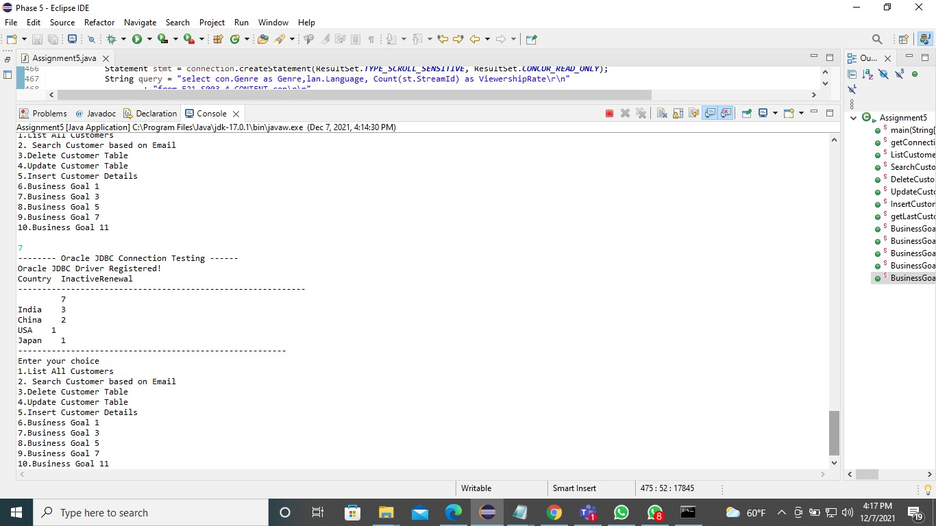

8. Generate a report of top viewed content(title) in each genre  
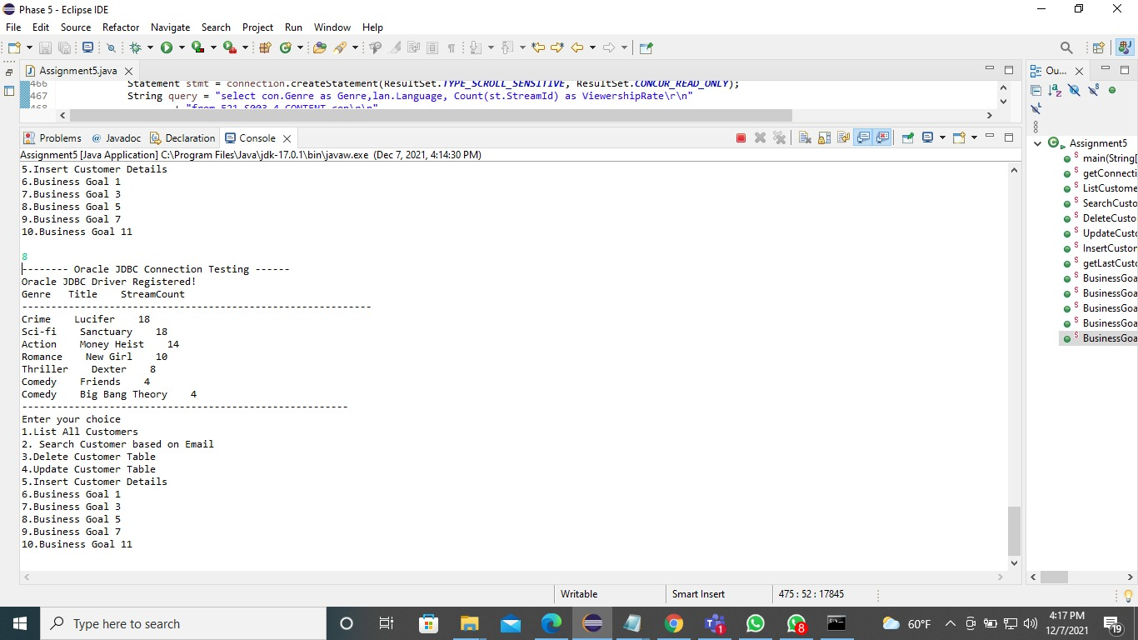

9. We will get the report of which type of device the users are using to watch /subscribe. With this data we shall know user with what age is comfortable with which kind of device. (0-18 define as Teen, 19-45 as Adult,>45 as Senior Adults)  
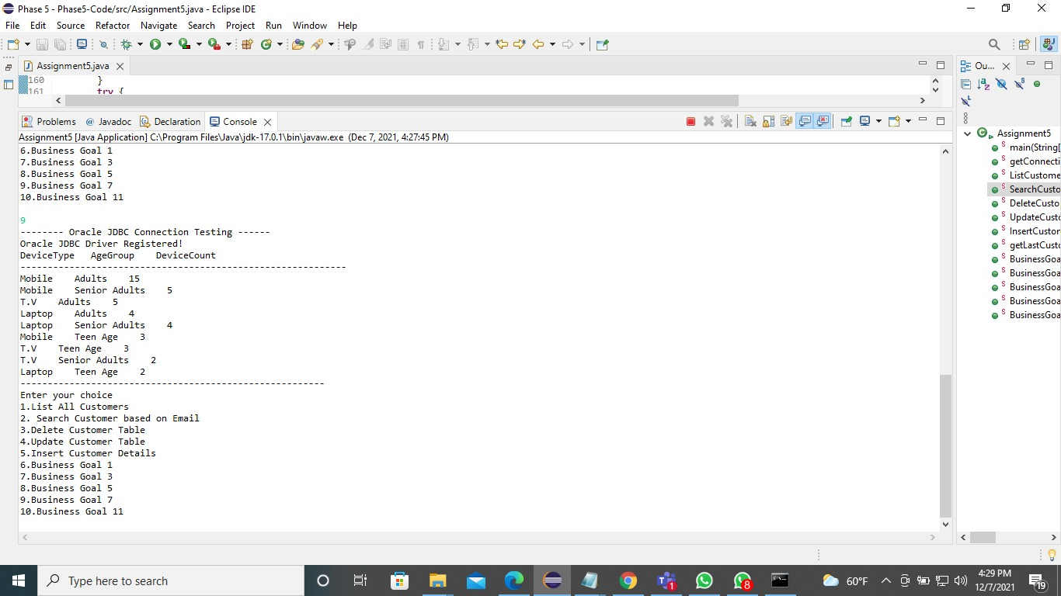

10. Generate a report of viewership rate of each language, genre and both language and genre  
